**CS/SDP 262 – Introduction to Computational Social Science**

**Fall 2020**

**Final Project Report**

**Mustafa Usman** (mu06166)

***and***

**Asad Raza** (ar06246)

**“آگاہی”**

**COVID-19 SPREAD SIMULATION**

# *Submitted to*

**Dr. Shah Jamal Alam**

**PURPOSE:**

Our group has planned to design an Agent based diseases-spread model which would be working on various factors that includes the demographic density, individuals already going through different diseases (e.g. Heart Disease, Diabetes, Asthma and Respiratory Infections) and how are they getting affected further by COVID-19. Also, we have included another risk factor varying from gender biasness in-terms of immunity and the impacts of COVID-19 overall. Hence, will generate the data, based on the results we would get from the above stated factors and compare and contrast various simulations running under numerous conditions.

**AGENTS/ ENTITIES:**

We have taken two kinds of agents, divided on the basis of gender.

* ***Male***: We have represented males in the society by randomly generating them as the symbol of *“persons”.* Population of men can be manipulated.
* ***Female:*** We have represented females in the society by randomly generating them as the symbol of *“default”.* Population of females can be manipulated.

Agents are characterized by the following attributes:

**COVID-pos:**Agents are distributed flag commands (i.e. True or False) which denotes either they are COVID positive or negative.

**Transmissible:**This attribute defines the ability of an agent to transmit the diseases any further.

**Immune:**Both the agents have independent sliders from which the % factor of immunity of the agents can be rendered.

**SOPs:** This entails whether the agents are following safety operating procedures or not, which might in turn effect Immune, Transmissible, COVID-pos attributes of an agent.

**Previous Health Diseases:**Each agent is assigned a random number ranging from 0 to 100 which denotes the % of immunity being affected due to any previous health diseases.

**Color:** Agents are color coded according different health statuses. They are defined as follows:

* **White:** Agents (Male & Female) that do not follow the SOPs.
* **Violet:** Agents (Male & Female) that does follows the SOPs.
* **Orange:** Agents (Male & Female) which are showing symptoms related to COVID-19 while following the SOPs.
* **Yellow:** Agents (Male & Female) which are showing symptoms related to COVID-19 while not following the SOPs.
* **Red:** Agents (Male & Female) who are infected with COVID-19.
* **Blue:** Agents (Male & Female) who once got infected but now are immune.

**Position:**Agents (Male & Female) are randomly distributed grid.

**Size:** Both of the agents have the same size i.e. 1.5.

**Shape:** Males in our simulation are categorized by the symbol of *“persons”* whereas the females are represented by the symbol of *“default”*.

**TIME:**

The tick (time step) in this model corresponds to one day.

**Mathematically:** Tick/24

**STATE/ GLOBAL VARIABLES:**

Our model comprises of **ten** global variables:

**%-previous-health-diseases:** The % of immunity being affected due to any previous health diseases, implemented as a slider in NetLogo ranging from 0 to 100. The default value is 50.

**male-population:** The total number of males distributed in the grid at the time of initialization. It is also implemented as a slider in NetLogo, which ranges from 0 to 100. The default value is 70.

**%-male-following-SOPs:** The % of the male population following the SOPs. It is implemented as a slider in NetLogo, which ranges from 0 to 100. The default value is 20.

**%-immunity-male*:*** The overall percentage immunity of the male population. It is implemented as a slider in NetLogo, which ranges from 0 to 100. The default value is 20.

**Female-population:** The total number of females distributed in the grid at the time of initialization. It is also implemented as a slider in NetLogo, which ranges from 0 to 100. The default value is 50.

**%-female-following-SOPs:** The % of the female population following the SOPs. It is implemented as a slider in NetLogo, which ranges from 0 to 100. The default value is 60.

**%-immunity-female:** The overall percentage immunity of the female population. It is implemented as a slider in NetLogo, which ranges from 0 to 100. The default value is 70.

**Death-toll*:*** The total number of agents dying due to COVID-19.

**Female-death-toll:** The total number of agents (Females) dying due to COVID-19.

**Male-death-toll:** The total number of agents (Males) dying due to COVID-19.

**STOP SIMULATION:**

Since the ticks for this simulation are represented as days, so mathematically:

**Ticks/24 = 100**

Whenever the total ticks equals to 2400 ticks (100 days), the simulation stops.

**PROCESS OVERVIEW AND SCHEDULING:**

On each tick following functions occur:

* Move-people
* Spread-diseases
* To-be-infectious

**SENSING:**

Agents can sense each other:

**Spread Diseases:** A COVID Positive / Transmissible agent can spread and infect other agents present with-in the in-radius of 1.

**AGENTS INTERACTIONS:**

The interactions among the agents include:

* Agents are randomly moving around the screen, bumping into each other.
* If an agents is COVID Positive, there is a chance it can transmit other agents.
* The probability of an agent being affected and the probability of an agents transmitting the diseases are determined by several factors (which are already explained above) and agent-agent interaction.

**RANDOMNESS:**

The randomness in our model occurs as follows:

* Our agents are randomly distributed all-over in the grid.
* At the start of every simulation, an agent (either male or female) would be randomly selected as COVID positive and would be represented as red from the very beginning.
* On every simulation, a random orientation of male-female agents are generated.
* Chance of agents affecting other agents:
* Chance for no-SOPs-people spread to no-SOPs-people:

***if random 100 < %-previous-health-diseases***

* Chance for no-SOPs-people spread to SOPs-people:

***if random-float 100 < 20***

* Chance for SOPs-people spread to no-SOPs-people:

***if random-float 100 < 10***

* Chance for SOPs-people spread to SOPs-people:

***if random-float 100 < 5***

**SETUP/ INITIALIZATION:**

The environment of our model is a single-spatial region inwhich the agents are:

* Agents are randomly moving.
* Agents are interacting / infecting each other
* Agents are changing color based on their current health statuses

**INPUT DATA:**

The input data for our simulation can be stated as follows:

* *%-previous-health-diseases*
* *male-population*
* *%-male-following-SOPs*
* *%-immunity-male*
* *female-population*
* *%-female-following-SOPs*
* *%-immunity-female*

**OUTPUTS:**

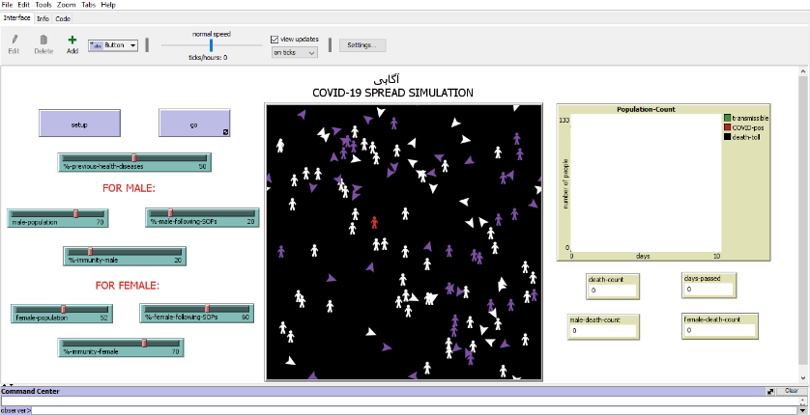The outputs are shown with the help of time-series plots and monitors. Attaching the snapshot of our simulation below:

**SUB MODELS:**

The main processes that occur at every time step (tick) in a model run are defined as follows:

* **Move-people:** Causing the agents to move randomly on the grid and interacting with each other.
* **Spread-diseases:** When the agents (Males and Females) are interacting with each other, this sub model accounts for the probability of the transmission of the diseases depending upon the conditions of immunity and SOPs.
* **To-be-infectious:**This sub model accounts for the COVID, affecting the agents. Here, the agents will not be considered infectious right away but will wait 2.5 days (2.5 days is the average from the data that people could have symptoms after 2 to 3 days).
* **Die:**This sub model accounts for the death of the agent if the immunity of the agent falls below a certain threshold, the agent if expected to die.

**REFERENCES:**

* **World Health Organization (WHO) – COVID 19:** [**https://www.who.int/health-topics/coronavirus#tab=tab_1**](https://www.who.int/health-topics/coronavirus%23tab=tab_1)
* **Virus Model (NetLogo – Models Library).**[**https://ccl.northwestern.edu/netlogo/models/Virus**](https://ccl.northwestern.edu/netlogo/models/Virus)
* **NetLogo Programming Guide.** [**https://ccl.northwestern.edu/netlogo/docs/programming.html**](https://ccl.northwestern.edu/netlogo/docs/programming.html)